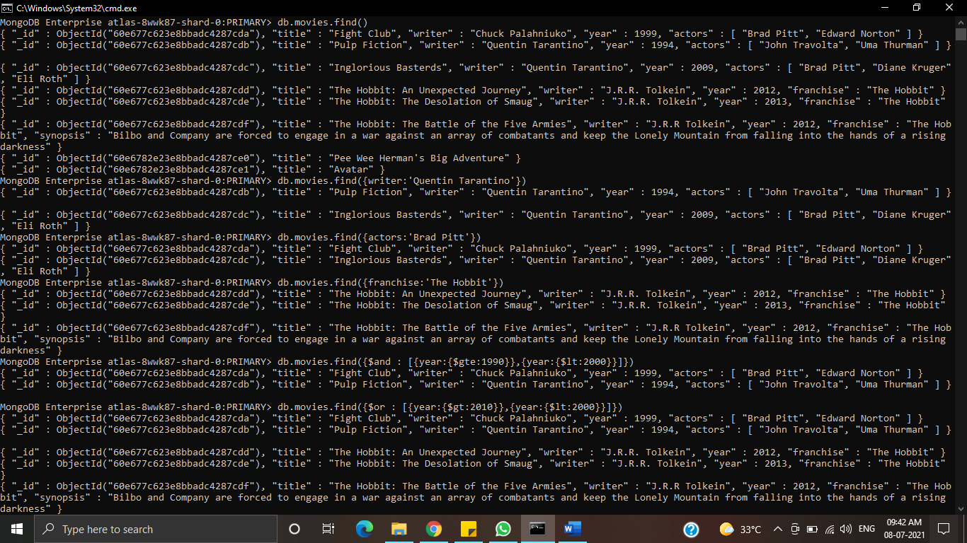**Assignment 1: Query/Find Documents:**



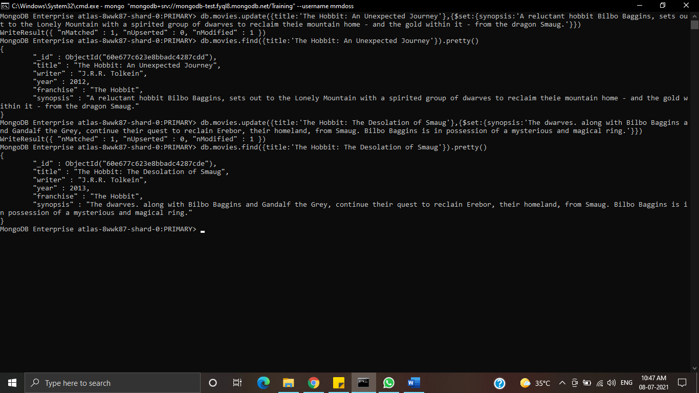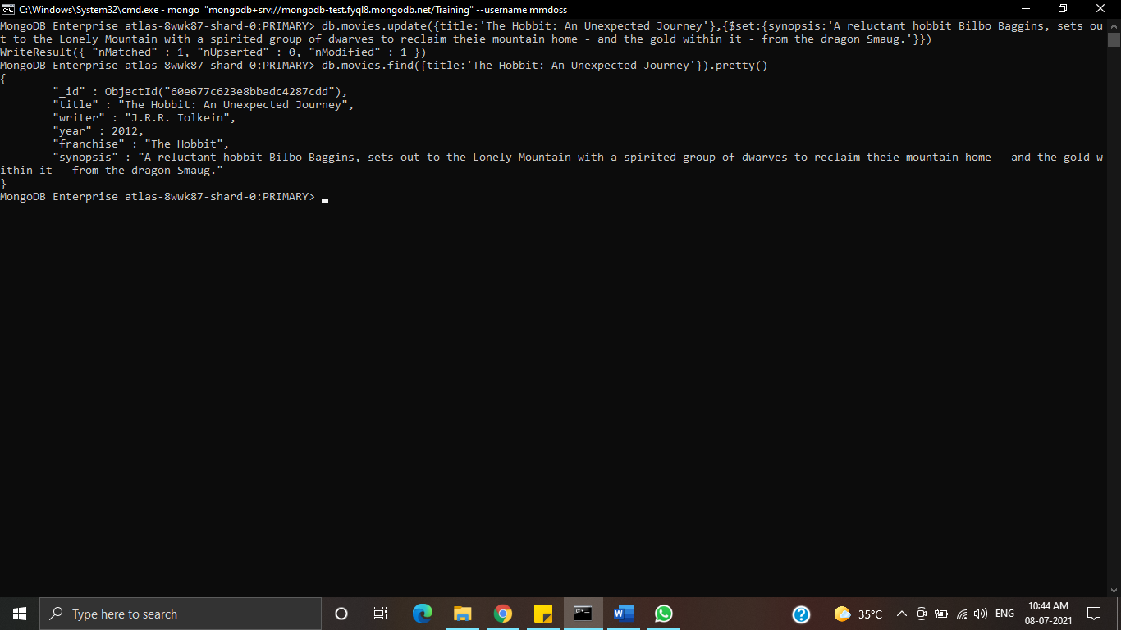**Assignment 1: Update Documents:**

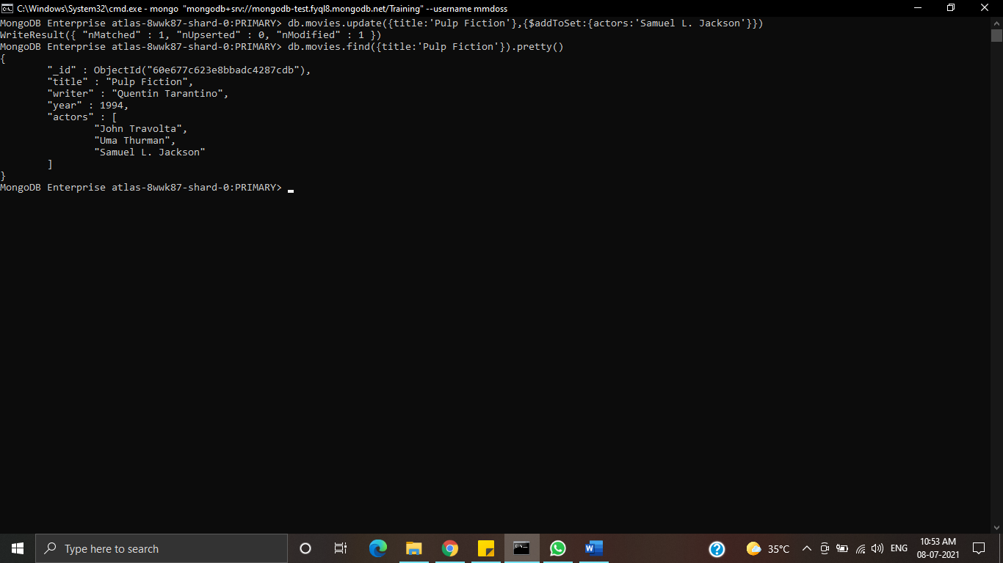

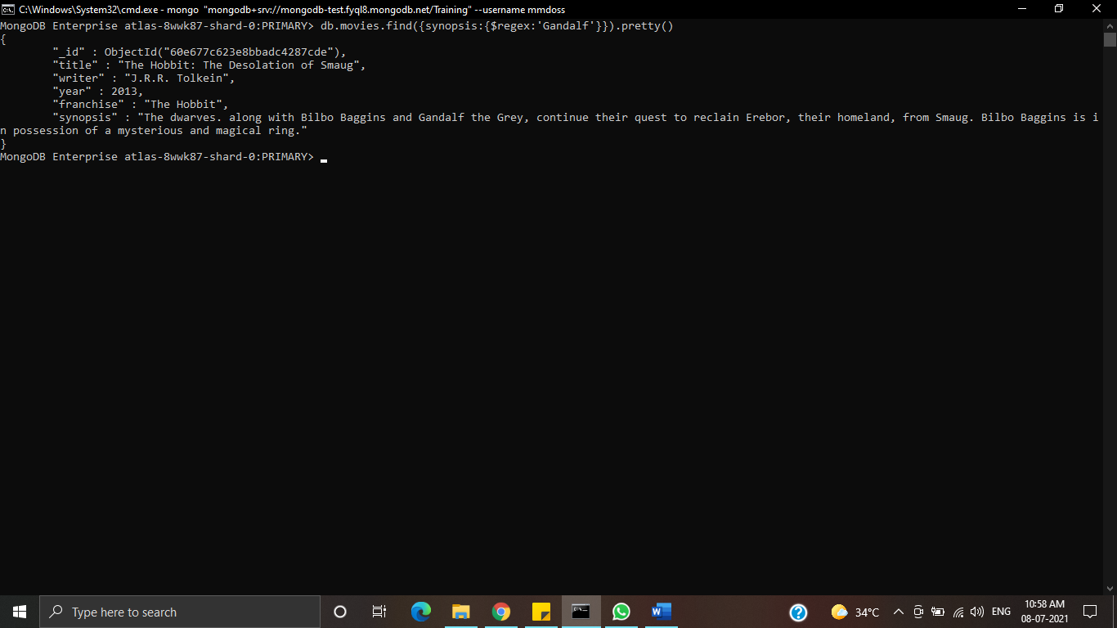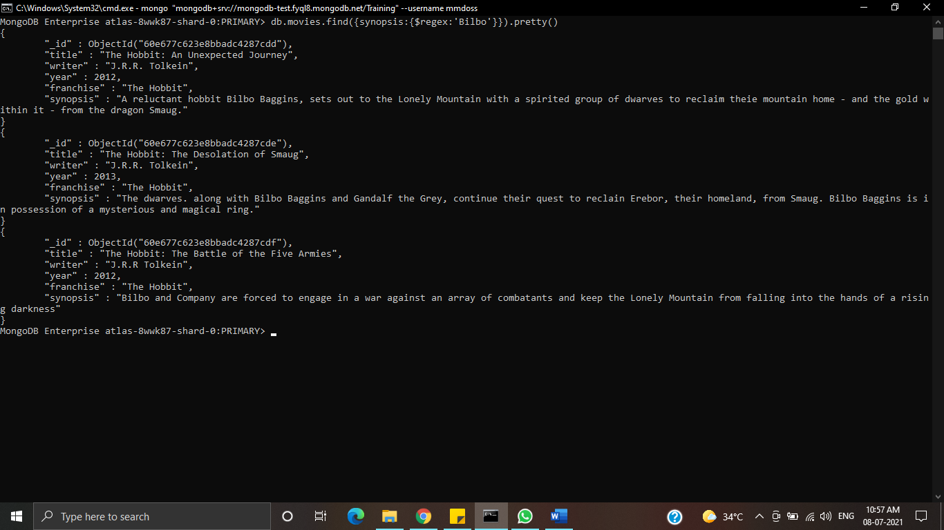**Assignment 1: Text Search:**

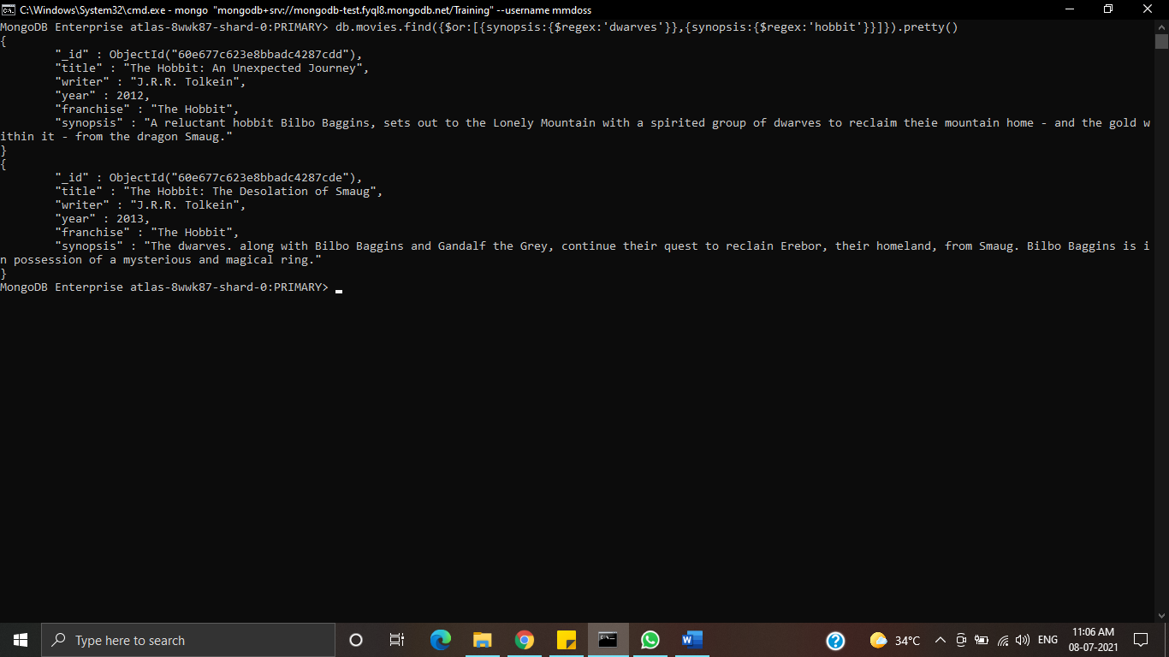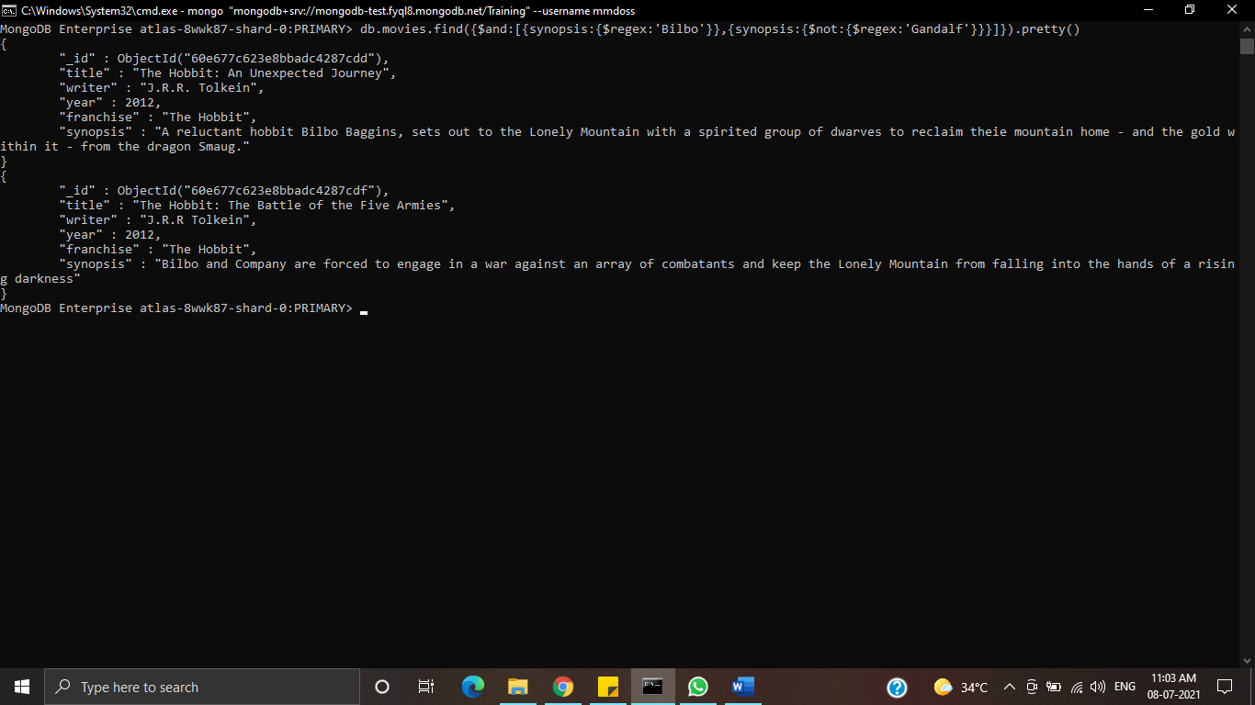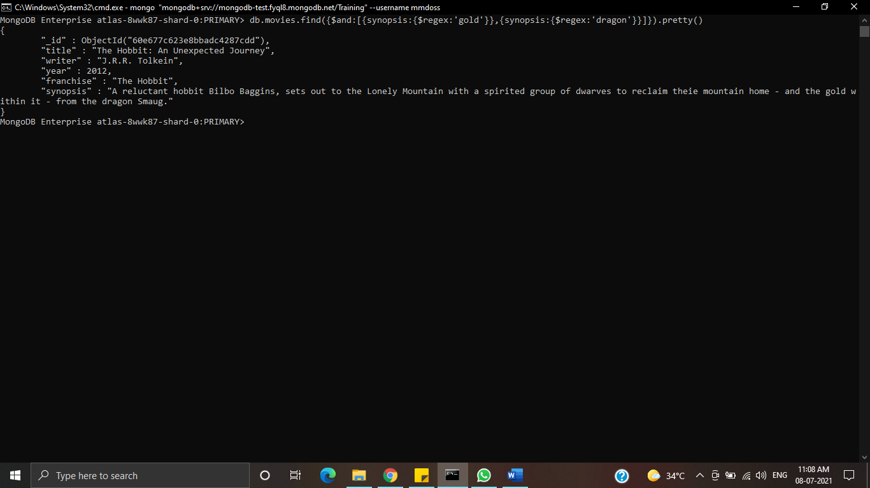

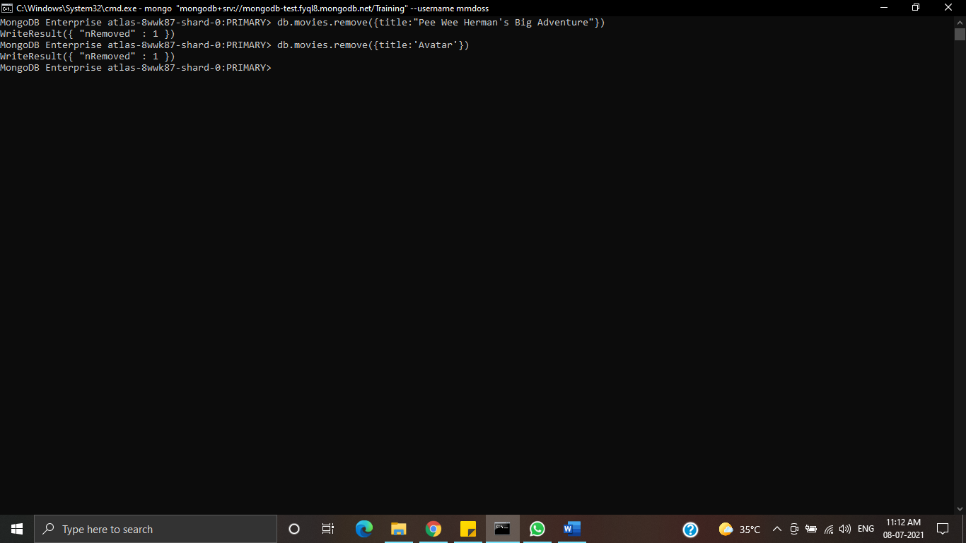**Assignment 1: Delete Documents:**

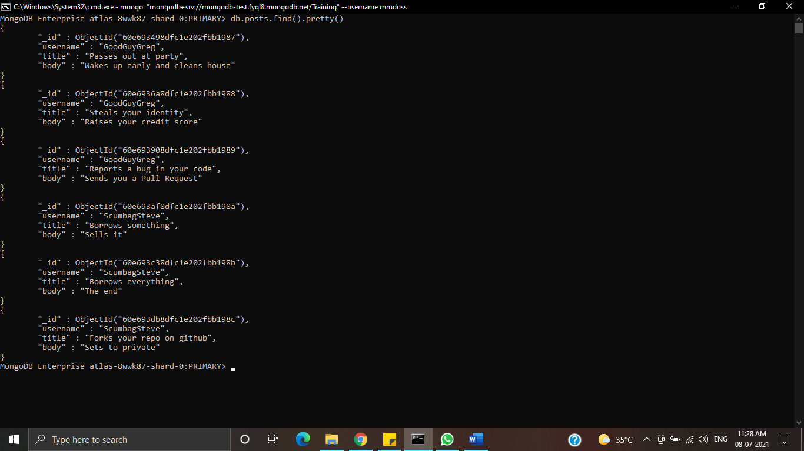**Assignment 1: Querying related collections:**



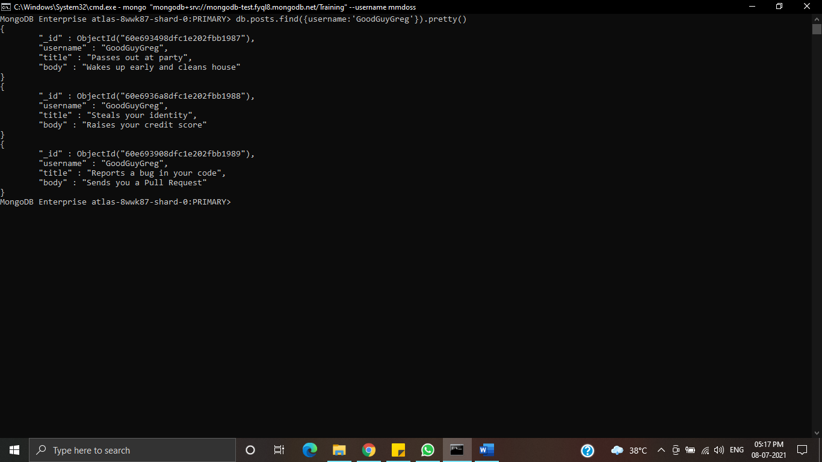

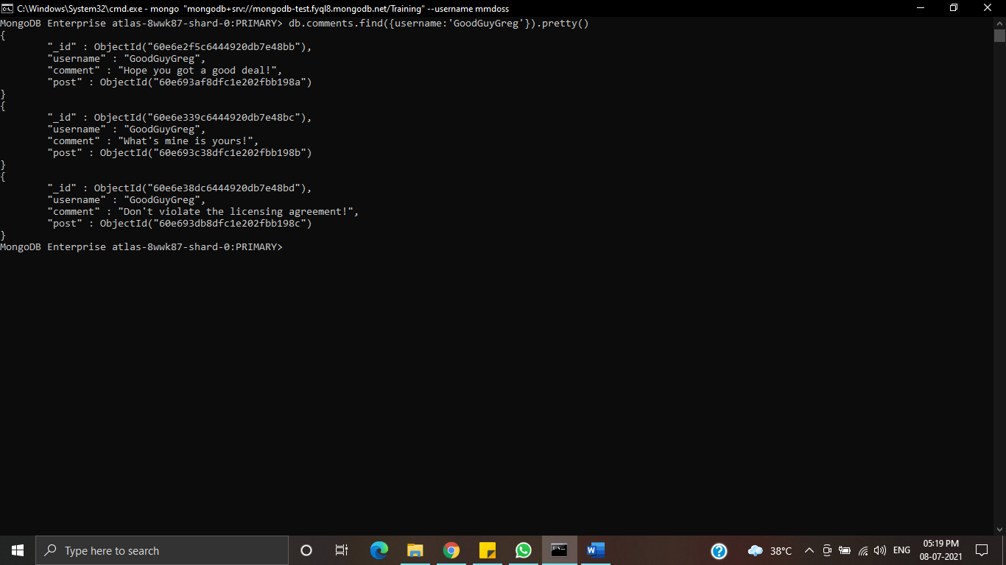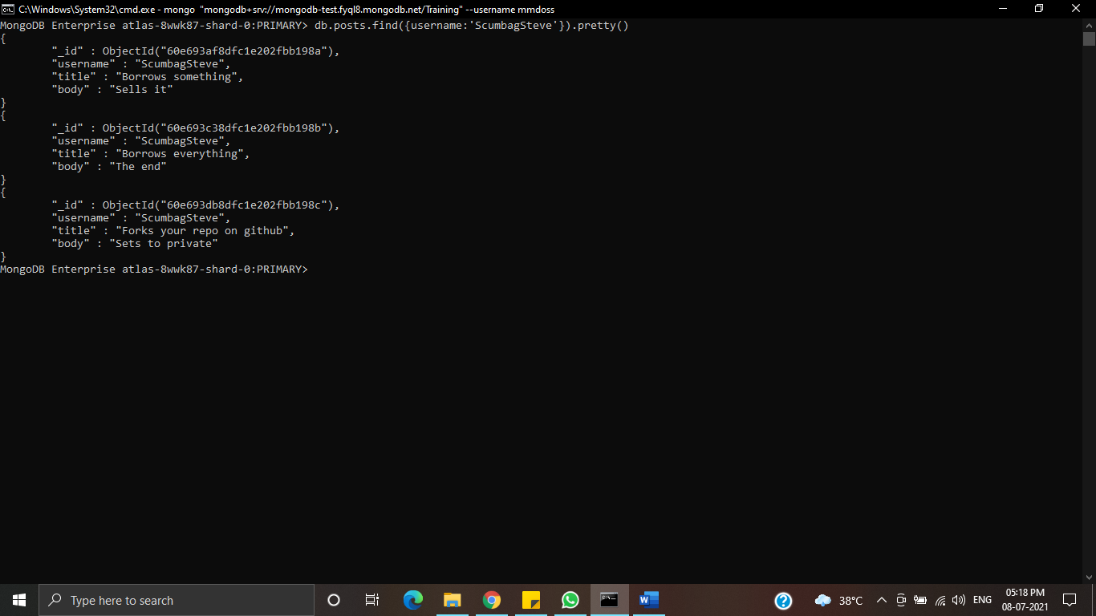

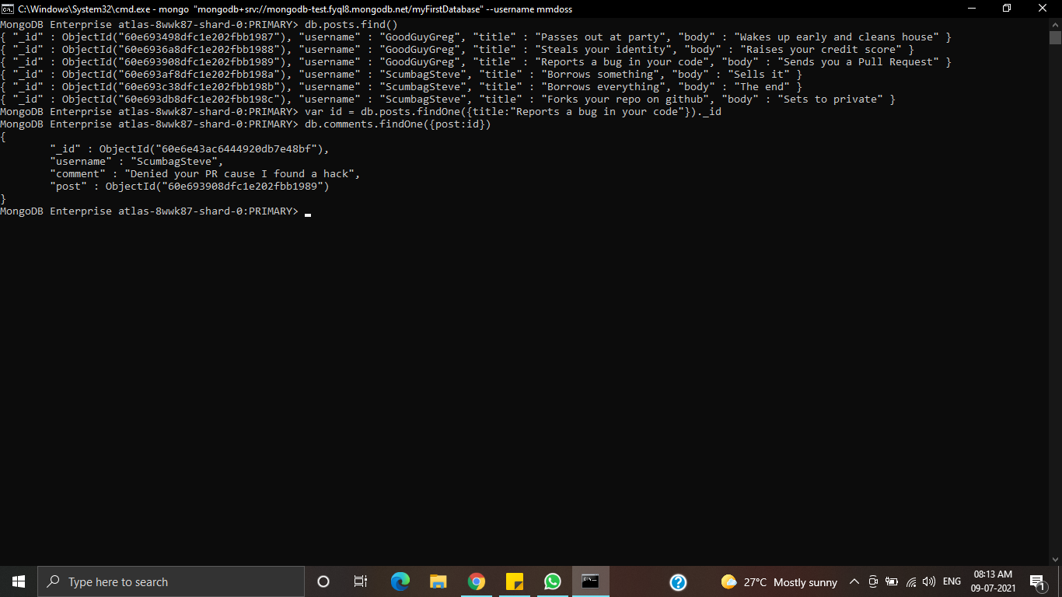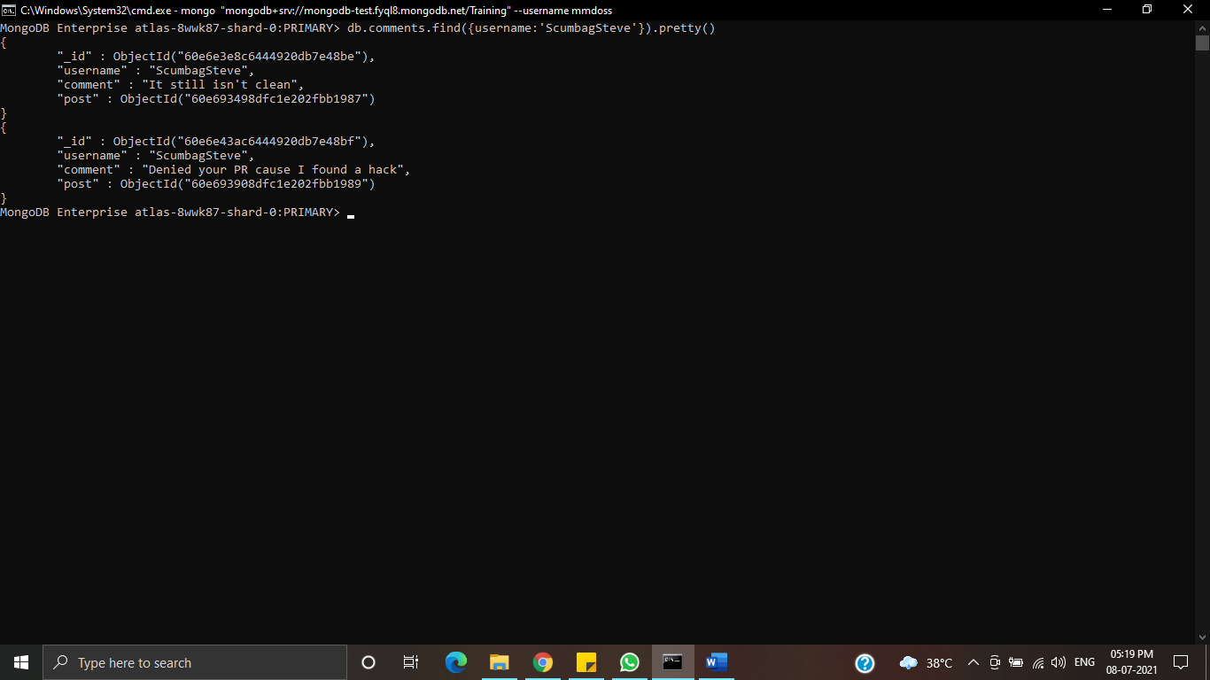

**Assignment 3:**

1. db.addresses.find()
2. db.addresses.find({},{restaurant_id:1,name:1,borough:1,cuisine:1})
3. db.addresses.find({},{restaurant_id:1,name:1,borough:1,cuisine:1,_id:0})
4. db.addresses.find({},{restaurant_id:1,name:1,borough:1,”address.zipcode”:1,_id:0})
5. db.addresses.find({borough:”Bronx”}).limit(5)
6. db.addresses.find({borough:”Bronx”})
7. db.addresses.find({borough:”Bronx”}).skip(5).limit(5)
8. db.addresses.find({“grades.score”:{$gt:90}})
9. db.addresses.find({$and:[{"grades.score":{$gt:80}},{"grades.score":{$lt:100}}]})
10. db.addresses.find({"address.coord.0":{$lt:-95.754168}})
11. db.addresses.find({$and:[{cuisine:{$not:{$regex:"American"}}},{"grades.score":{$gt:70}},{"address.coord.0":{$lt:-65.754168}}]})
12. db.addresses.find({$and:[{cuisine:{$not:{$regex:"American"}}},{"grades.score":{$gt:70}},{"address.coord.1":{$lt:-65.754168}}]})
13. db.addresses.find({$and:[{cuisine:{$not:{$regex:"American"}}},{"grades.grade":"A"},{borough:{$not:{$regex:"Brooklyn"}}}]}).sort({cuisine:-1})
14. db.addresses.find({name:/^Wil/},{restaurant_id:1,name:1,borough:1,cuisine:1})
15. db.addresses.find({name:/ces$/},{restaurant_id:1,name:1,borough:1,cuisine:1})
16. db.addresses.find({name:/.*Reg.*/},{restaurant_id:1,name:1,borough:1,cuisine:1})
17. db.addresses.find({borough:"Bronx",$or:[{cuisine:"American"},{cuisine:"Chinese"}]})
18. db.addresses.find({$or:[{borough:"Staten Island"},{borough:"Queens"},{borough:"Bronx"},{borough:"Brooklyn"}]},{restaurant_id:1,name:1,borough:1,cuisine:1})
19. db.addresses.find({$and:[{borough:{$not:/Bronx/}},{borough:{$not:/Brooklyn/}},{borough:{$not:/Staten Island/}},{borough:{$not:/Queens/}}]},{restaurant_id:1,name:1,borough:1,cuisine:1})
20. db.addresses.find({"grades.score":{$lte:10}},{restaurant_id:1,name:1,borough:1,cuisine:1})
21. db.addresses.find({$or:[{name:/^Wil/},{$and:[{cuisine:{$not:/American/}},{cuisine:{$not:/Chinese/}}]}]},{restaurant_id:1,name:1,borough:1,cuisine:1})
22. db.addresses.find({"grades.grade":"A","grades.score":11,"grades.date":ISODate('2014-08-11T00:00:00Z')}, {restaurant_id:1,name:1,grades:1})
23. db.addresses.find({"grades.1.grade":"A","grades.1.score":9,"grades.1.date":ISODate('2014-08-11T00:00:00Z')}, {restaurant_id:1,name:1,grades:1})
24. db.addresses.find({$and:[{"address.coord.1":{$gt:42}},{"address.coord.1":{$lte:52}}]},{restaurant_id:1,name:1,"address":1})
25. db.addresses.find().sort({name:1})
26. db.addresses.find().sort({name:-1})
27. db.addresses.find().sort({cuisine:1,borough:-1})
28. db.addresses.find({“address.coord”:{$type:1}})
29. .
30. db.addresses.find({name:/.*mon.*/}, {name:1,borough:1,cuisine:1,"address.coord":1})
31. db.addresses.find({name:/^Mad/}, {name:1,borough:1,cuisine:1,"address.coord":1})